Lab 9
Course
CourseID | Name | EntryQualification
C01 | Diploma | 3 credits in O Level
C02 | Degree | 3 credits in A Level
C03 | Master | Degree in any computing field
C04 | Foundation | 5 credits in O Level

Primary key: CourseID
Student
StudentID | Name | Gender | DOB | CourseID
ST01 | Helen | Female | 2 Feb 1999 | C01
ST02 | Karen | Female | 15 Sept 2000 | C02
ST03 | Peter | Male | 28 April 1997 | C02
ST04 | Shaun | Male | 30 June 2001 | C03

Primary key: StudentID, Foreign key: CourseID
Subject
SubjectID | Name | CourseID
SU01 | SAD | C01
SU02 | IDB | C01
SU03 | ISWE | C02
SU04 | CPP | C02
SU05 | Java | C03
SU06 | NNT | C04
SU07 | DAS | C04

Primary key: SubjectID, Foreign key: CourseID

Attributes | Data Type
CourseID | nvarchar(50)
Name | nvarchar(50)
EntryQualification | nvarchar(50)

Attributes | Data Type
StudentID | nvarchar(50)
Name | nvarchar(50)
Gender | nvarchar(50)
DOB | Date
CourseID | nvarchar(50)

Attributes | Data Type
SubjectID | nvarchar(50)
Name | nvarchar(50)
CourseID | nvarchar(50)

- Create a new Database Lab9
- Create 3 tables given above (remember to specify the primary & foreign key)
- Insert each row of data into the tables
create database Lab_9;

Create table Course(
Course_ID nvarchar(50) Not Null Primary Key,
Name nvarchar(50),
Entry_Qualiafication nvarchar(50)
);

Create table Student(
Student_ID nvarchar(50) Not Null Primary Key,
Name nvarchar(50),
Gender nvarchar(50),
DOB date,
Course_ID nvarchar(50) Foreign Key References Course(Course_ID)
);

Create table Subject(
Subject_ID nvarchar(50) Not Null Primary Key,
Name nvarchar(50),
Course_ID nvarchar(50) Foreign Key References Course(Course_ID)
);

Insert into Course values
('C01','Diploma','3 Credits in O Level'),
('C02','Degree','3 Credits in A Level'),
('C03','Master','Degree in Any Computing Field'),
('C04','Foundation','5 Credits in O Level');

Insert into Student values
('ST01','Helen','Female','2 Feb 1999','C01'),
('ST02','Karen','Female','15 September 2000','C02'),
('ST03','Peter','Male','28 April 1997','C02'),
('ST04','Shaun','Male','30 June 2001','C03');

Insert into Subject values
('SU01','SAD','C01'),
('SU02','IDB','C01'),
('SU03','ISWE','C02'),
('SU04','CPP','C02'),
('SU05','Java','C03'),
('SU06','NNT','C04'),
('SU07','DAS','C04');

- Generate the database diagram
Execute this statement first:
Alter Authorization on Database::Lab9 To [sa];
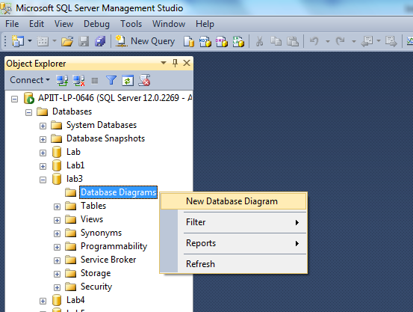

ALter Authorization on Database::Lab_9 to [sa];
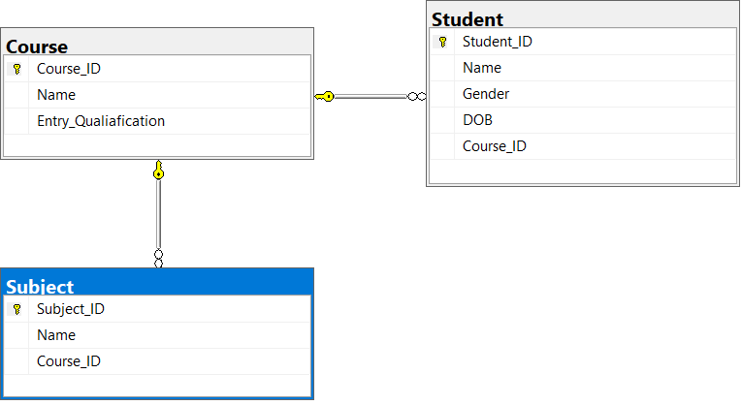

- Display StudentID, Name and Age (derive Age from DOB)
SELECT Student_ID, Name, Year(getdate())-year(DOB) as Age
FROM Student;

- List all students whose age is more than 18
SELECT Student_ID, Name, Gender, Year(getdate())-year(DOB) as Age, Course_ID
FROM Student
WHERE Year(getdate())-year(DOB)>18;

- Inner Join Course, Student and Subject table
Select *
From ((Course
INNER JOIN Student ON Course.Course_ID = Student.Course_ID)
INNER JOIN Subject ON Course.Course_ID = Subject.Course_ID);

- Join all columns from Course and Subject table without using the keyword ‘JOIN’
Select *
FROM Course, Subject
WHERE Course.Course_ID = Subject.Course_ID;

- Join all columns from Course, Student and Subject table without using the keyword ‘JOIN’
Select *
FROM Course, Student, Subject
WHERE Course.Course_ID = Student.Course_ID AND Course.Course_ID = Subject.Course_ID;

- Left Join Course with Student table, order by Course name (Course is left, Student is right)
SELECT * FROM Course
LEFT JOIN Student ON Course.Course_ID = Student.Course_ID
Order By Course.Name;

- Right Join Course with Student table, order by Student name (Course is left, Student is right)
(*Examine the result from Q10 & Q11, make sure you understand the difference)
SELECT * FROM Course
RIGHT JOIN Student ON Course.Course_ID = Student.Course_ID Order By Student.Name;

Reference:
https://www.w3schools.com/sql/default.asp

Examples of extracting data from more than 1 table without using JOIN

select p.name, p.address, b.name, b.author
From Publisher p, Book b
Where p.PublisherID = b.PublisherID;

select Publisher.name, Publisher.address, Book.name, Book.author
From Publisher inner join book
on Publisher.PublisherID = Book.PublisherID;

Full Lines of Codes:
/*
create database Lab_9;

Create table Course(
Course_ID nvarchar(50) Not Null Primary Key,
Name nvarchar(50),
Entry_Qualiafication nvarchar(50)
);

Create table Student(
Student_ID nvarchar(50) Not Null Primary Key,
Name nvarchar(50),
Gender nvarchar(50),
DOB date,
Course_ID nvarchar(50) Foreign Key References Course(Course_ID)
);

Create table Subject(
Subject_ID nvarchar(50) Not Null Primary Key,
Name nvarchar(50),
Course_ID nvarchar(50) Foreign Key References Course(Course_ID)
);

Insert into Course values
('C01','Diploma','3 Credits in O Level'),
('C02','Degree','3 Credits in A Level'),
('C03','Master','Degree in Any Computing Field'),
('C04','Foundation','5 Credits in O Level');

Insert into Student values
('ST01','Helen','Female','2 Feb 1999','C01'),
('ST02','Karen','Female','15 September 2000','C02'),
('ST03','Peter','Male','28 April 1997','C02'),
('ST04','Shaun','Male','30 June 2001','C03');

Insert into Subject values
('SU01','SAD','C01'),
('SU02','IDB','C01'),
('SU03','ISWE','C02'),
('SU04','CPP','C02'),
('SU05','Java','C03'),
('SU06','NNT','C04'),
('SU07','DAS','C04');

ALter Authorization on Database::Lab_9 to [sa];

SELECT Student_ID, Name, Year(getdate())-year(DOB) as Age
FROM Student;

SELECT Student_ID, Name, Gender, Year(getdate())-year(DOB) as Age, Course_ID
FROM Student
WHERE Year(getdate())-year(DOB)>18;

Select *
From ((Course
INNER JOIN Student ON Course.Course_ID = Student.Course_ID)
INNER JOIN Subject ON Course.Course_ID = Subject.Course_ID);

Select *
FROM Course, Subject
WHERE Course.Course_ID = Subject.Course_ID;

Select *
FROM Course, Student, Subject
WHERE Course.Course_ID = Student.Course_ID AND Course.Course_ID = Subject.Course_ID;

SELECT * FROM Course
LEFT JOIN Student ON Course.Course_ID = Student.Course_ID
Order By Course.Name;

SELECT * FROM Course
RIGHT JOIN Student ON Course.Course_ID = Student.Course_ID Order By Student.Name;
*/

